|  |  |  |
| --- | --- | --- |
| Test part | Possible mark | Your mark |
| Multiple choice | 50 |  |

HUMAN BIOLOGICAL SCIENCE. YEAR 12. 2013.

Dating, Primates and Human Ancestors Topic Test.

***Multiple choice***

**Use a ball point or ink pen to colour in** the letter that represents the best answer from the choice of answers . Marks are not deducted for wrong answers.

1. Which of the following would contain the greatest number of species?
2. Kingdom
3. Phylum
4. Species
5. Genus.

Look at the three skulls below. Use these drawing to answer questions 2, 3 and 4.

|  |  |  |
| --- | --- | --- |
| A | B | C |
| http://3.bp.blogspot.com/_vZtAOUAS7HQ/SDD6C3TtgHI/AAAAAAAAAIc/b-16E1IpaCk/s400/skull_study_profile-400.png | http://www.transientvisions.com/images/gorilla_skull.jpg | http://4.bp.blogspot.com/_prb792zvLfg/S7qyhS7Gt0I/AAAAAAAAAtg/QUdz7-X3dlU/s1600/Australopithecus.jpg |

1. Which skull is likely to have the greatest cranial capacity in proportion to the total skull size?
2. A
3. B
4. C
5. A and C will be equal.
6. Which skull has a large diastema?
7. A and B
8. B only
9. A only
10. C only
11. Which skull/s are not hominin?
12. A
13. B
14. C
15. A and C
16. Fire and advanced tool culture allowed which of the following?
17. Less impact of environmental selective pressures on Hominins and greater manipulation of the environment by Hominins.
18. More impact of environmental selective pressures on Hominins and greater manipulation of the environment by Hominins.
19. Greater predation on Hominins.
20. Less impact of selective pressures on Hominins and less manipulation of the environment by Hominins.
21. Which of the following statements about the move to an agricultural lifestyle by Humans is **FALSE**?
22. Its long term affect was an increase in population numbers.
23. It caused people to move from hunter gathering lifestyles.
24. It is first seen with Homo erectus.
25. It is not seen in all parts of the world.
26. Which of the following lists the primates in order of evolution, going from simple to more complex.
27. Old world monkeys, Lemur, new world monkeys, apes and Humans.
28. New world monkeys, Old world monkeys and apes.
29. Old world monkeys, new world monkeys and lemurs.
30. Apes, Lemurs, monkeys and Humans.
31. Which of the following will have the largest olfactory center relative to total brain size?
32. New world Monkey
33. Old world Monkey
34. Homo erectus
35. Lemur
36. Which of the following is **not** true of Homo erectus?
37. It had a sloping forehead compared to Homo sapiens.
38. It was able to live in colder climates than Homo habilis.
39. It had a similar cranial capacity to Homo neanderthalensis.
40. It had pentadactyl hands.
41. Which one of the following changes is irrelevant in the evolution of humans?
42. An increase in convolutions of the cerebral cortex.
43. Precision grip.
44. Increased complexity of tool culture.
45. A move from grain to root vegetables in the diet.

11. A gene giving resistance to a root parasite is transferred from rye grass to a genetically modified type of rice. This process is an example of:

a. deletion.

b. transgenics.

c. gene probes.

d. DNA sequencing.

12. The Sanger method has been useful in which of the following?

a. Gene therapy.

b. The Human genome project.

c. Transgenics.

d. All of the above.

The following two questions relate to the use of biotechnology in law enforcement.

13. At a crime scene a small skin sample is found. It contains a small amount of valid DNA. This DNA can be replicated and a much larger sample made using which of the following?

a. DNA polymerase.

b. DNA transcriptase.

c. DNA ligase.

d. RNA ligase.

14. Once enough of the DNA has been produced from the sample at the crime scene, it can be compared to the DNA of suspects. This is done using a process called:

a. DNA cloning.

b. DNA profiling.

c. DNA transcription.

d. Gene probing.

15. Which of the following is a hereditary disease?

a. Malaria.

b. Huntington’ Disease.

c. blood poisoning.

d. tuberculosis.

16. Which of the following is **not** a potential use of gene therapy?

a. replacing defective genes that cause infectious diseases.

b. replacing defective genes that cause hereditary diseases.

c. replacing missing genes that are causing disorders.

d. treating cystic fibrosis.

17. Electro gel Electrophoresis works because:

a. DNA has a negative charge.

b. DNA can be denatured by heat.

c. DNA Strands of DNA of different length will move through the gel at different rates.

d. All of the above.

18. The reason for an increase in the incidence of osteoporosis, osteoarthritis, Alzheimer’s disease and Parkinson’s disease is:

a. An increase in obesity in Western Countries.

b. A reduction in physical activity by people in Western Countries.

c. An increase in the average lifespan of people.

d. An increase in the consumption of fatty foods and foods containing simplified sugars.

19. Which of the following is **not** a potential benefit of The Human Genome project?

1. Improved diagnosis of disease.
2. Earlier detection of genetic predispositions to disease including [breast cancer](http://en.wikipedia.org/wiki/Breast_cancer), [disorders of homeostasis](http://en.wikipedia.org/wiki/Blood_clotting), [liver](http://en.wikipedia.org/wiki/Liver) diseases and many others.
3. Improvements in civic hygiene.
4. Gene therapy.

20. Carbon C14 dating is used for:

a. Dating of inorganic mineral artifacts.

b. Relative dating of organic matter.

c. Absolute dating of organic matter.

d. Stratigraphy.

The following three questions refer to the written passage below. A gene for a desired protein was cut out of the DNA of the carrot plant. A ring of DNA found in bacteria was cut open. The gene cut out of the carrot was inserted and “glued” into this ring of DNA. The DNA ring was placed back in bacteria. A huge colony of the bacteria was grown. The colony of the bacteria produced a large amount of the desired protein.

21. In the procedure above the bacterial ring of DNA would be called:

a. artificial chromosome vector.

b. plasmid vector.

c. natural chromosome vector.

d. artificial chromosome donor.

22. The desired gene cut from the carrot DNA could be cut using:

a. RNA polymerase

b. DNA polymerase.

c. Restriction enzymes.

d. DNA ligase.

23. The desired gene could be added to the bacterial ring of DNA using:

a. RNA polymerase

b. DNA polymerase.

c. Restriction enzymes.

d. DNA ligase.

24. Look at this diagram of a type of stone tool.

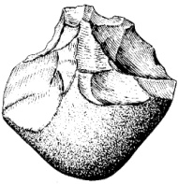

The name of this type of tool and the organism associated with it are:

1. Acheulean and Australopithecus.
2. Spear and Jackson and Homo sapiens.
3. Oldowan and Australopithecus.
4. Oldowan and Homo habilis.

25. which of the following have the lifestyle paired with the correct organism?

a. Hunter gatherer and Homo erectus.

b. Scavenger gatherer and Homo erectus.

c. Agriculture and Australopithecus.

d. Scavenger gatherer and Homo neanderthalensis.

26. Which of the following organisms are matched best to their cranial capacity?

a. Homo neanderthalensis 450cc.

b. Homo sapien 1500cc.

c. Australopithecus 1000cc.

d. Homo habilis 1500cc.

27. Which of the following statements about Homo erectus is **NOT** correct?

a. Their geographical distribution was wider than Homo habilis.

b. They were able to have more of an impact on the environment than Homo habilis.

c. They were not as able to clear land as Homo habilis.

d. They were more able to reduce the amount of parasites in meat than Homo habilis.

Read this article and use it to answer the questions that follow.

In 1912, Charles Dawson, an amateur palaeontologist, found what was thought to be an early human skull. It was name “Piltdown Man”. It was believed to be a very ancient human.  It was popularly referred to as "the missing link" in human evolution.  In 1949, the Piltdown bones were finally tested for fluorine content and a fraud became apparent.  The skull and jaw clearly were not from the same time period. This has since been backed up by C14 dating. It consisted of a 700 year old human skull (cranium) bones, a 500-year-old lower jaw bone of an [orangutan](http://en.wikipedia.org/wiki/Orangutan) and [chimpanzee](http://en.wikipedia.org/wiki/Chimpanzee) mineral fossil teeth. The bones had originally came from different sites and been reburied together.

28. Which of the following is most likely to be true?

1. The Jaw would have contained more Fluorine than the Skull bones.
2. The skull bones would have contained more Fluorine than the jaw.
3. The skull and jaw bones would have had the same fluorine content.
4. There is not enough information in the article above to determine which bone would have the most fluorine.

29. Which of the following is **FALSE?**

1. The chimpanzee teeth could be C14 dated.
2. The Jaw bone could be C14 date.
3. The skull bones could be C14 dated.
4. The chimpanzee teeth could not be C14 dated.

30. If Piltdown Man had been an earlier human ancestor his prognation would have been:

1. Greater than modern humans.
2. Greater than modern Lemurs.
3. Less than modern humans.
4. Undeterminable from the evidence above.

31. The polymerase chain reaction

a. makes numerous copies of DNA from small samples of DNA.

b. relies on changes of temperature to copy DNA.

c. uses RNA polymerase.

d. is useful at crime scenes when large amounts of DNA are present.

Read this article and use it to answer two the questions that follow.

In 1996, excavation of a Neanderthal cave site uncovered, what some claim to be, the section of a flute made from the femur bone of a young bear. The artifact is dated between 60,000 to 50,000 years old, making it possibly the oldest musical instrument ever found.



32. This artifact shows that:

1. Neanderthals had religious beliefs.
2. Neanderthals played on the first Jethro Tull album.
3. Neanderthals had bear cults.
4. Neanderthal tools were fine enough to cut holes in bone.

33. This artifact could be absolute dated using:

1. Carbon C14 dating.
2. Fluorine dating.
3. Stratigraphy.
4. A form of radio isotope dating other than carbon C14 dating.

34. Look at this diagram and use it to choose the correct answers for questions 34 and 35.

[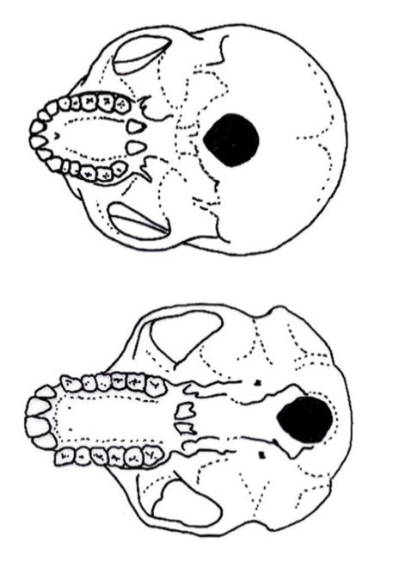](http://www.google.com.au/url?sa=i&rct=j&q=human+foramen+magnum+and+ape+foramen+magnum&source=images&cd=&cad=rja&docid=GZu10pa2Sq9xUM&tbnid=Z1eJ4IXbkGP6DM:&ved=0CAUQjRw&url=http://australianmuseum.net.au/image/Undersides-of-a-human-and-a-chimpanzee-skull&ei=okUyUoKYLMWFkAWA9YH4Bg&psig=AFQjCNHfHu1Y0VC_PCg78305teS8wfw0TA&ust=1379112690280839)

* 1. The skull on the left is a bipedal primate with reduced prognation and a diastema.
  2. The skull on the left is a bipedal primate with large prognastion and a diastema.
  3. The skull on the right is a bipedal primate with a large prognation and no diastema.
  4. The skull on the right is a bipedal primate with reduced prognation and no diastema.

35.

a. The animal with the skull on the left will have large wedge like lumber vertebrae.

b. The animal with the skull on the right will have large wedge like lumber vertebrae.

c. The animal with the skull on the left will have large wedge like thoracic vertebrae.

d. The animal with the skull on the right will have large wedge like thoracic vertebrae.

Look at the diagram below and use it to complete the question that follows.

[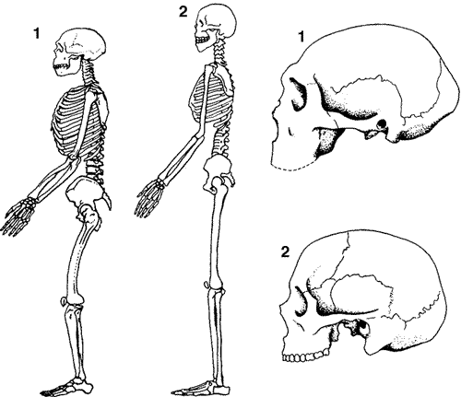](http://www.google.com.au/url?sa=i&rct=j&q=homo%20erectus%20skeleton&source=images&cd=&cad=rja&docid=4nIRzdatyL7srM&tbnid=Jrr_VY6bsOXmkM:&ved=0CAUQjRw&url=http://indiaeng.com/Tsunami-2004--Andaman%20fault/Toba%20Volcano,%20ch_5%20-%20Human%20evolution.htm&ei=lEMyUsSmPMzQkQXK44HwCw&psig=AFQjCNF-yv1GCRD9maKl1AScOl7Pi8Adww&ust=1379112121921145)

36. both of these skeleton show:

a. an arboreal bipedal primate with pentadactyl limbs.

b. an arboreal quadruped primate with reduced prognation.

c. a bipedal primate with a foramen magnum towards the back of the skull.

d. a bipedal primate with a large cranial capacity and two foot arches.

37. The Human Genome project was made possible by:

a. the development of DNA sequencing techniques and advances in computer technology.

b. the development of protein and DNA sequencing techniques.

c. Electron microscopy and electro gel phoresis.

d. embryo stem cell research and Electron microscopy.

38. Mary has just has a child. She says that Bob is the father. Bob says he is not the father. Bob says he thinks his ex-best friend Larry is the father. A DNA paternity test is done. The DNA profile that results from the test is shown below.

[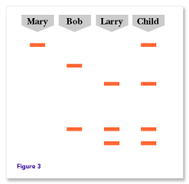](http://www.google.com.au/url?sa=i&rct=j&q=dna%20testing%20for%20paternity&source=images&cd=&cad=rja&docid=sBEetW_KdrC23M&tbnid=OPeSTOy4R7AAsM:&ved=0CAUQjRw&url=http://genetics.thetech.org/ask/ask20&ei=pU0yUu2OI4fjkgWq6ICAAQ&psig=AFQjCNGkZTLnvQAogUUqN-zvEhwREsxaSg&ust=1379114784831978)

* 1. Bob is the father of the child.
  2. Larry is the father of the child.
  3. Neither Bob nor Larry is the father.
  4. Mary just isn’t that “kind of Girl”.

39. The large prognation of the primate called the Sifaka infers that:

a. It was not very reliant on olfaction.

b. it was more reliant on olfaction than modern humans.

c. it had a large diastema.

d. it had an enlarged occipital lobe of the cerebrum.

40. C14 has a half-life of 5730 years. How much will be left after 11,460 years?

a. 25%

b. 50%

c. 25%

d. 12.5%

41. Dendrochronology states the principle that.

a. The rings to the outside of a tree trunk are younger than the rings nearer the middle.

b. The rings to the outside of a tree trunk are older than the rings nearer the middle.

c. The rings to the outside of a tree trunk are thicker than the rings nearer the middle.

d. The rings to the outside of a tree trunk are thinner than the rings nearer the middle.

42. Which of the statement listed below allow the method of stratigraphy and the principle of superposition to be used in dating?

a. Deeper layers of soil will contain organisms that evolved after organisms that are found in layers nearer the surface.

b. fossils nearer the surface of the soil are younger than fossils deeper down in the soil.

c. Deeper layers of soil will contain younger index fossils.

d. Stratigraphy does not give relative dating. It gives absolute dating.

43. One technique that has sped up DNA profiling is:

a. The use of higher voltage gels.

b. Dye (often fluorescent).

c. The use of ligase enzymes.

d. The use of proteins sequence analysis.

44. Which of the following has **not** been a benefit of the Human genome project?

1. Improved diagnosis of disease.
2. Earlier detection of genetic predispositions to disease .
3. Rational drug design .
4. The commercial ownership of genes.

45. Which of the following is **not** an adaptions to bipedalism?

a. Femur long allowing a longer stride.

b. The top of the femur is shaped to provide a carrying angle to direct load through the knees and in turn feet.

c. The bones of the knee joint are stronger towards the outside of the leg.

d. The bones of the knee joint are stronger towards the inside of the leg.

46. All of knowledge, technology, beliefs, roles, concepts of the universe, material objects and possessions seen in a group of people, is called the:

a. Culture.

b. Religion.

c. Society.

d. Heritage.

47. The darker area of the map below shows the known distribution of a hominin.

[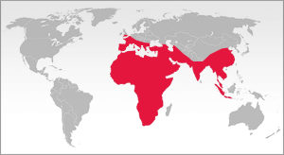](http://www.google.com.au/url?sa=i&rct=j&q=&esrc=s&frm=1&source=images&cd=&cad=rja&docid=_jNFRze1ZwLqwM&tbnid=jlC_bwSlEKYkPM:&ved=0CAUQjRw&url=http://www.bradshawfoundation.com/origins/homo_erectus.php&ei=zgo0Uo_LLKq3iwKErIGQBg&psig=AFQjCNEB5RjrcPxy-1ya9PwquHE6eD0vgg&ust=1379228666514146)

It is most likely to be which of the organisms listed below?

1. Australopithecus.
2. Homo habilis.
3. Homo erectus.
4. Homo sapiens.

48. The most significant advantage of forward facing eyes is that it enables better:

1. colour perception
2. three dimensional perception
3. range of vision
4. visual activity

49. As a proportion of total lifespan, which of the following primates would you expect to spend the longest period as a juvenile?

1. A lemur
2. A spider monkey
3. Homo erectus.
4. An Orang-utan

50. Which of the following was not a result of the change from hunter gather lifestyles to agricultural lifestyles?

a. People developing specialist skills.

b. A reduction on the impact of humans on the environment.

c. An increase in population size.

d. The development of permanent larger buildings.